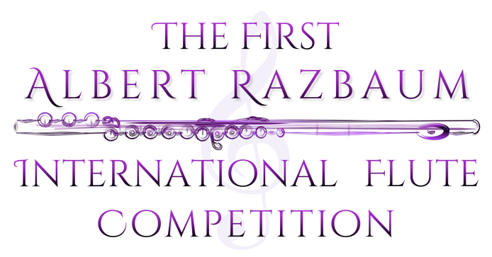

REGLAMENT

Of the 1st Albert Razbaum International Flute Competition
8-15 June 2020
MOSCOW

CONDITIONS
- The event will be held at Alexandr Skriabin museum (Bolshoy Nikolopeskovskiy pereulok, 11)
Flutists aged from 16 to 32 can take part in the competition.
Deadline for sending applications is the 20st of March 2020.
The following documents should be attached to the application form:
- copy of the passport or a valid ID - proof of the payment for the entrance (registration) fee
- 2 recommendation letters written by two well-known musicians - one photo of good quality (.jpg)
All the documents need to be sent on the following address: competitionmfc@gmail.com
The documents sent after the deadline (March 20) will not be considered.
Living costs and accomodation for the participants and their pianists during the period of the competition is organised by the participants.
The entrance fee is: 70 Euros.
The amount (entrance fee) should be paid in full on the account of the Moscow Flute Center (button “Registration fee” at www.magicflutecenter.com) by March 20 2020
In case of cancellation of participation the entrance fee will not be refunded.
For the participants who are chosen for the live audition the registration fee is: 35 Euros.
The registration fee needs to be paid by April 20 2020
Programme:

Preliminary round (by video)
Gabriel Faure​ ​ ​- «Fantaisie» op.79 for flute and piano

First round (Live audition)

1) Georg Philipp​ Telemann​ ​ - «Fantasia» for solo flute /one from 12 to be chosen/
2) Edison Denisov​ - «Prelude and Aria» for Flute and Piano
3) Philippe Gaubert - «Nocturne et Allegro Scherzando» for Flute

Second round (Live audition)
1) choose​ one of the following compositions:
a. Theobald Boehm - «Fantasy sur des air eccossaise» op.25
b. Anatoli Samonov - «Sonata» for Flute and Piano
2) W. A. Mozart - «Sonata» k304 (any edition or arrangement)
3) Yuko Uebayashi - «Sonata» for Flute and Piano, movements​ 2 and 3

JURY
Ulla Miilmann
Philippe Jundt
Silvia Careddu
Denis Lupachev
Irina Stachinskaya

COMPETITION REGULATIONS
The preliminary round is done by video auditions. The deadline to submit application form and the recordings is March 1 2020
No more than 15 people will be allowed to the final round.
The order of participants is decided with a draw during the opening ceremony and will be kept for the rest of the competition. All participants need to attend the opening ceremony which will be held on X June 2020.
The order of the pieces is decided by the participants.

PRIZES

1 prize - 150000 rubles
2 prize - 100000 rubles
3 prize - 50000 rubles

All finalists will be awarded with honored diplomas. The member of the jury can award special prizes for best performances of obligatory pieces.

Agreement
For processing of personal data

I,__________________________________passport no __________________________________

Issued_________________________________________________________________________
(By whom, where)
According to the articles of 3 and 9 of the Federal law from 27 July 2006 no. 152-FZ con personal data" I give my permission to use my personal details within the 1st Albert Razbaum International Flute Competition 2020
This agreement is valid for one year.
This agreement can be cancelled with a written application.

" " ____________ 202__ г. | __________________
Signature

